MI308 GPU测试(7.8)

检测
- rvs
- 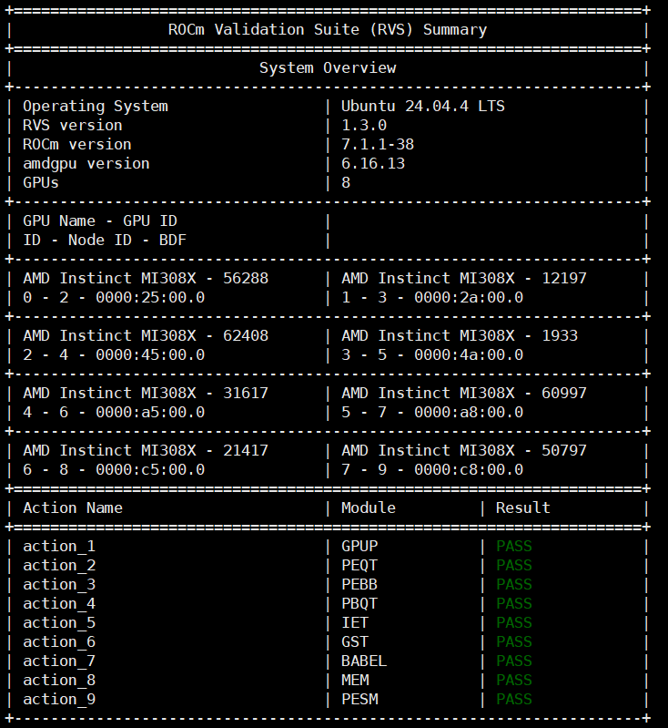

DeepSeek-v4-Flash-FP8

VLLM

rocm/atom-dev:vllm-v0.22.0-nightly_20260707

基准测试
- 启动参数
docker run -itd \
--ipc=host \
--network=host \
--privileged \
--cap-add=CAP_SYS_ADMIN \
--cap-add=SYS_PTRACE \
--device=/dev/kfd \
--device=/dev/dri \
--security-opt seccomp=unconfined \
--security-opt apparmor=unconfined \
--group-add video \
--env "NCCL_IB_GID_INDEX=3" \
--privileged \
--name vllm_dsv4 \
--shm-size 128G \
--entrypoint=/bin/bash \
-e HIP_VISIBLE_DEVICES=0,1,2,3,4,5,6,7 \
-e NCCL_IB_GID_INDEX=3 \
-e AITER_BF16_FP8_MOE_BOUND=0 \
-e ATOM_MOE_GU_ITLV=1 \
-e VLLM_ROCM_USE_TRITON_ROPE=1 \
-w /workspace \
-v /volumes/oss1/models:/data/models \
rocm/atom-dev:vllm-v0.22.0-nightly_20260706 \
-c "vllm serve /data/models/DeepSeek-V4-Flash-FP8 \
--served-model-name=DeepSeek-V4-Flash-FP8 \
--host 0.0.0.0 \
--port 8001 \
--dtype auto \
--tensor-parallel-size 8 \
--distributed-executor-backend mp \
--trust-remote-code \
--gpu-memory-utilization 0.6 \
--tokenizer-mode deepseek_v4 \
--block-size 16 \
--async-scheduling \
--no-enable-prefix-caching \
--compilation-config '{\"cudagraph_mode\":\"FULL_AND_PIECEWISE\"}' \
- &>> /data/models/deepseek_v4_flash_fp8.log 2>&1"
- 请求测试
- 请求回复对不上，答非所问
poc@node1:~$ time curl http://0.0.0.0:8001/v1/chat/completions -H "Content-Type: application/json" -d '{
"model": "DeepSeek-V4-Flash-FP8",
"messages": [
{"role": "user", "content": "1+1等于几"}
],
"temperature": 0.6,
"top_p": 0.95,
"top_k": 20,
"max_tokens": 2048
}'

{"id":"chatcmpl-b9ee46e40b506fa9","object":"chat.completion","created":1783480380,"model":"DeepSeek-V4-Flash-FP8","choices":[{"index":0,"message":{"role":"assistant","content":"2025年新高考4月月题中\n\n1、一、单选题 honour左加题分\n\n1、下列函数函数月向角A、已知函数函数\n\n 已知函数平面直线等平面平面平面平行 B、若直线函数、已知##解、已知．已知、、满足函数直角四、求函数直线直线根直线根长中，已知函数满足，则在平面平面平面、上任意、，","refusal":null,"annotations":null,"audio":null,"function_call":null,"tool_calls":[],"reasoning":null},"logprobs":null,"finish_reason":"stop","stop_reason":null,"token_ids":null,"routed_experts":null}],"service_tier":null,"system_fingerprint":"vllm-0.22.1.dev0+g0b3ba88f1.d20260706-tp8-33e4f076","usage":{"prompt_tokens":9,"total_tokens":99,"completion_tokens":90,"prompt_tokens_details":null},"prompt_logprobs":null,"prompt_token_ids":null,"prompt_text":null,"kv_transfer_params":null}
real 0m8.249s
user 0m0.004s
sys 0m0.011s

- Benchmark测试
CONC=1
vllm bench serve \
--backend openai-chat \
--base-url "http://127.0.0.1:8001" \
--endpoint /v1/chat/completions \
--model DeepSeek-V4-Flash-FP8 \
--tokenizer /data/models/DeepSeek-V4-Flash-FP8 \
--tokenizer-mode deepseek_v4 \
--dataset-name random \
--random-input-len "6144" \
--random-output-len "1024" \
--num-prompts $(( $CONC * 10 )) \
--request-rate inf \
--max-concurrency $CONC \
--ignore-eos \
--percentile-metrics ttft,tpot,itl,e2el
- 1并发测试结果
============ Serving Benchmark Result ============
Successful requests: 10
Failed requests: 0
Maximum request concurrency: 1
Benchmark duration (s): 191.82
Total input tokens: 61480
Total generated tokens: 10240
Request throughput (req/s): 0.05
Output token throughput (tok/s): 53.38
Peak output token throughput (tok/s): 57.00
Peak concurrent requests: 2.00
Total token throughput (tok/s): 373.89
---------------Time to First Token----------------
Mean TTFT (ms): 951.47
Median TTFT (ms): 773.22
P99 TTFT (ms): 2401.68
-----Time per Output Token (excl. 1st token)------
Mean TPOT (ms): 17.82
Median TPOT (ms): 17.82
P99 TPOT (ms): 17.83
---------------Inter-token Latency----------------
Mean ITL (ms): 17.80
Median ITL (ms): 17.82
P99 ITL (ms): 18.06
----------------End-to-end Latency----------------
Mean E2EL (ms): 19181.41
Median E2EL (ms): 19005.14
P99 E2EL (ms): 20625.04
==================================================
- 16并发测试结果
============ Serving Benchmark Result ============
Successful requests: 160
Failed requests: 0
Maximum request concurrency: 16
Benchmark duration (s): 331.26
Total input tokens: 983680
Total generated tokens: 163840
Request throughput (req/s): 0.48
Output token throughput (tok/s): 494.60
Peak output token throughput (tok/s): 785.00
Peak concurrent requests: 23.00
Total token throughput (tok/s): 3464.13
---------------Time to First Token----------------
Mean TTFT (ms): 4476.15
Median TTFT (ms): 4943.80
P99 TTFT (ms): 11849.85
-----Time per Output Token (excl. 1st token)------
Mean TPOT (ms): 27.99
Median TPOT (ms): 27.44
P99 TPOT (ms): 31.65
---------------Inter-token Latency----------------
Mean ITL (ms): 27.97
Median ITL (ms): 20.76
P99 ITL (ms): 22.42
----------------End-to-end Latency----------------
Mean E2EL (ms): 33113.71
Median E2EL (ms): 32974.00
P99 E2EL (ms): 40432.21
==================================================
- 6并发测试结果
============ Serving Benchmark Result ============
Successful requests: 60
Failed requests: 0
Maximum request concurrency: 6
Benchmark duration (s): 238.73
Total input tokens: 368880
Total generated tokens: 61440
Request throughput (req/s): 0.25
Output token throughput (tok/s): 257.36
Peak output token throughput (tok/s): 318.00
Peak concurrent requests: 12.00
Total token throughput (tok/s): 1802.54
---------------Time to First Token----------------
Mean TTFT (ms): 2762.88
Median TTFT (ms): 3268.94
P99 TTFT (ms): 4572.33
-----Time per Output Token (excl. 1st token)------
Mean TPOT (ms): 20.63
Median TPOT (ms): 20.18
P99 TPOT (ms): 22.59
---------------Inter-token Latency----------------
Mean ITL (ms): 20.61
Median ITL (ms): 19.01
P99 ITL (ms): 19.40
----------------End-to-end Latency----------------
Mean E2EL (ms): 23869.20
Median E2EL (ms): 23858.52
P99 E2EL (ms): 24656.55
==================================================

Benchmark 测试结果
并发数 | 请求数 | 输入长度 | 输出长度 | Input TPM (w) | Output TPM (w) | Total TPM (w) | Mean TTFT (s) | Mean TPOT (ms) | Mean E2E (s)
1 | 10 | 6148 | 1024 | 1.923 | 0.320 | 2.243 | 0.951 | 17.82 | 19.18
6 | 60 | 6148 | 1024 | 9.271 | 1.544 | 10.815 | 2.763 | 20.63 | 23.87
16 | 160 | 6148 | 1024 | 17.817 | 2.968 | 20.785 | 4.476 | 27.99 | 33.11

SGLANG

lmsysorg/sglang-rocm:v0.5.13.post1-rocm720-mi30x-20260623

基准测试
- 启动参数
docker run -itd \
--ipc=host \
--network=host \
--privileged \
--cap-add=CAP_SYS_ADMIN \
--cap-add=SYS_PTRACE \
--device=/dev/kfd \
--device=/dev/dri \
--security-opt seccomp=unconfined \
--security-opt apparmor=unconfined \
--group-add video \
--name sglang_dsv4 \
--shm-size 128G \
-w /workspace \
-v /volumes/oss1/models:/data/models \
-e HIP_VISIBLE_DEVICES=0,1,2,3,4,5,6,7 \
-e SGLANG_USE_ROCM700A=0 \
-e SGLANG_HACK_FLASHMLA_BACKEND=unified_kv_triton \
-e AITER_BF16_FP8_MOE_BOUND=0 \
--entrypoint=/bin/bash \
lmsysorg/sglang-rocm:v0.5.13.post1-rocm720-mi30x-20260623 \
-c "sglang serve \
--trust-remote-code \
--model-path /data/models/DeepSeek-V4-Flash-FP8 \
--tp 8 \
--attention-backend dsv4 \
--page-size 256 \
--mem-fraction-static 0.90 \
--swa-full-tokens-ratio 0.1 \
--disable-shared-experts-fusion \
--kv-cache-dtype fp8_e4m3 \
--chunked-prefill-size 8192 \
--speculative-algorithm EAGLE \
--speculative-num-steps 3 \
--speculative-eagle-topk 1 \
--speculative-num-draft-tokens 4 \
--host 0.0.0.0 \
--port 30000 \
&>> /data/models/sglang_deepseek_v4.log 2>&1"
- 请求测试
time curl http://0.0.0.0:30000/v1/chat/completions -H "Content-Type: application/json" -d '{
"model": "DeepSeek-V4-Flash-FP8",
"messages": [
{"role": "user", "content": "现在你的身份是刘备，而我是关羽，请在这个背景下完成对话。大哥，我等何日光复大汉"}
],
"temperature": 0.6,
"top_p": 0.95,
"top_k": 20,
"max_tokens": 2048
}'

{"id":"e535fc0019d245d78dca363c91a3374a","object":"chat.completion","created":1783505396,"model":"DeepSeek-V4-Flash-FP8","choices":[{"index":0,"message":{"role":"assistant","content":"（执手落泪）二弟啊！自桃园结义至今，你我兄弟辗转三十载。今虽据荆州一隅，然观天下大势——曹操新败于汉中，孙权虎踞江东，此诚汉室存亡之秋也。待军师孔明整顿军备，云长你且厉兵秣马，待来年秋收粮足，便当挥师宛洛，祭献帝于九泉！","reasoning_content":null,"tool_calls":null},"logprobs":null,"finish_reason":"stop","matched_stop":1}],"usage":{"prompt_tokens":27,"total_tokens":125,"completion_tokens":98,"prompt_tokens_details":null,"reasoning_tokens":0},"metadata":{"weight_version":"default"}}
real 0m4.761s
user 0m0.004s
sys 0m0.010s
- Benchmark
CONC=16

python -m sglang.bench_serving \
--backend sglang-oai-chat \
--base-url "http://127.0.0.1:30000" \
--model /data/models/DeepSeek-V4-Flash-FP8 \
--tokenizer /data/models/DeepSeek-V4-Flash-FP8 \
--dataset-name random \
--dataset-path /data/models/ShareGPT_V3_unfiltered_cleaned_split.json \
--random-input-len 6144 \
--random-output-len 1024 \
--random-range-ratio 1.0 \
--num-prompts $(( $CONC * 8 )) \
--request-rate inf \
--max-concurrency $CONC
- 16并发
============ Serving Benchmark Result ============
Backend: sglang-oai-chat
Traffic request rate: inf
Max request concurrency: 16
Successful requests: 128
Benchmark duration (s): 354.99
Total input tokens: 786432
Total input text tokens: 786432
Total generated tokens: 131072
Total generated tokens (retokenized): 129428
Request throughput (req/s): 0.36
Input token throughput (tok/s): 2215.39
Output token throughput (tok/s): 369.23
Peak output token throughput (tok/s): 272.00
Peak concurrent requests: 18
Total token throughput (tok/s): 2584.62
Concurrency: 15.42
Accept length: 2.51
----------------End-to-End Latency----------------
Mean E2E Latency (ms): 42772.07
Median E2E Latency (ms): 41678.63
P90 E2E Latency (ms): 54662.97
P95 E2E Latency (ms): 63463.80
P99 E2E Latency (ms): 69361.77
---------------Time to First Token----------------
Mean TTFT (ms): 3266.58
Median TTFT (ms): 960.65
P90 TTFT (ms): 9511.37
P95 TTFT (ms): 19173.50
P99 TTFT (ms): 25527.33
-----Time per Output Token (excl. 1st token)------
Mean TPOT (ms): 38.62
Median TPOT (ms): 38.94
P90 TPOT (ms): 46.73
P95 TPOT (ms): 50.53
P99 TPOT (ms): 57.57
---------------Inter-Token Latency----------------
Mean ITL (ms): 38.99
Median ITL (ms): 20.04
P90 ITL (ms): 59.34
P95 ITL (ms): 60.38
P99 ITL (ms): 411.13
Max ITL (ms): 18773.20
==================================================

